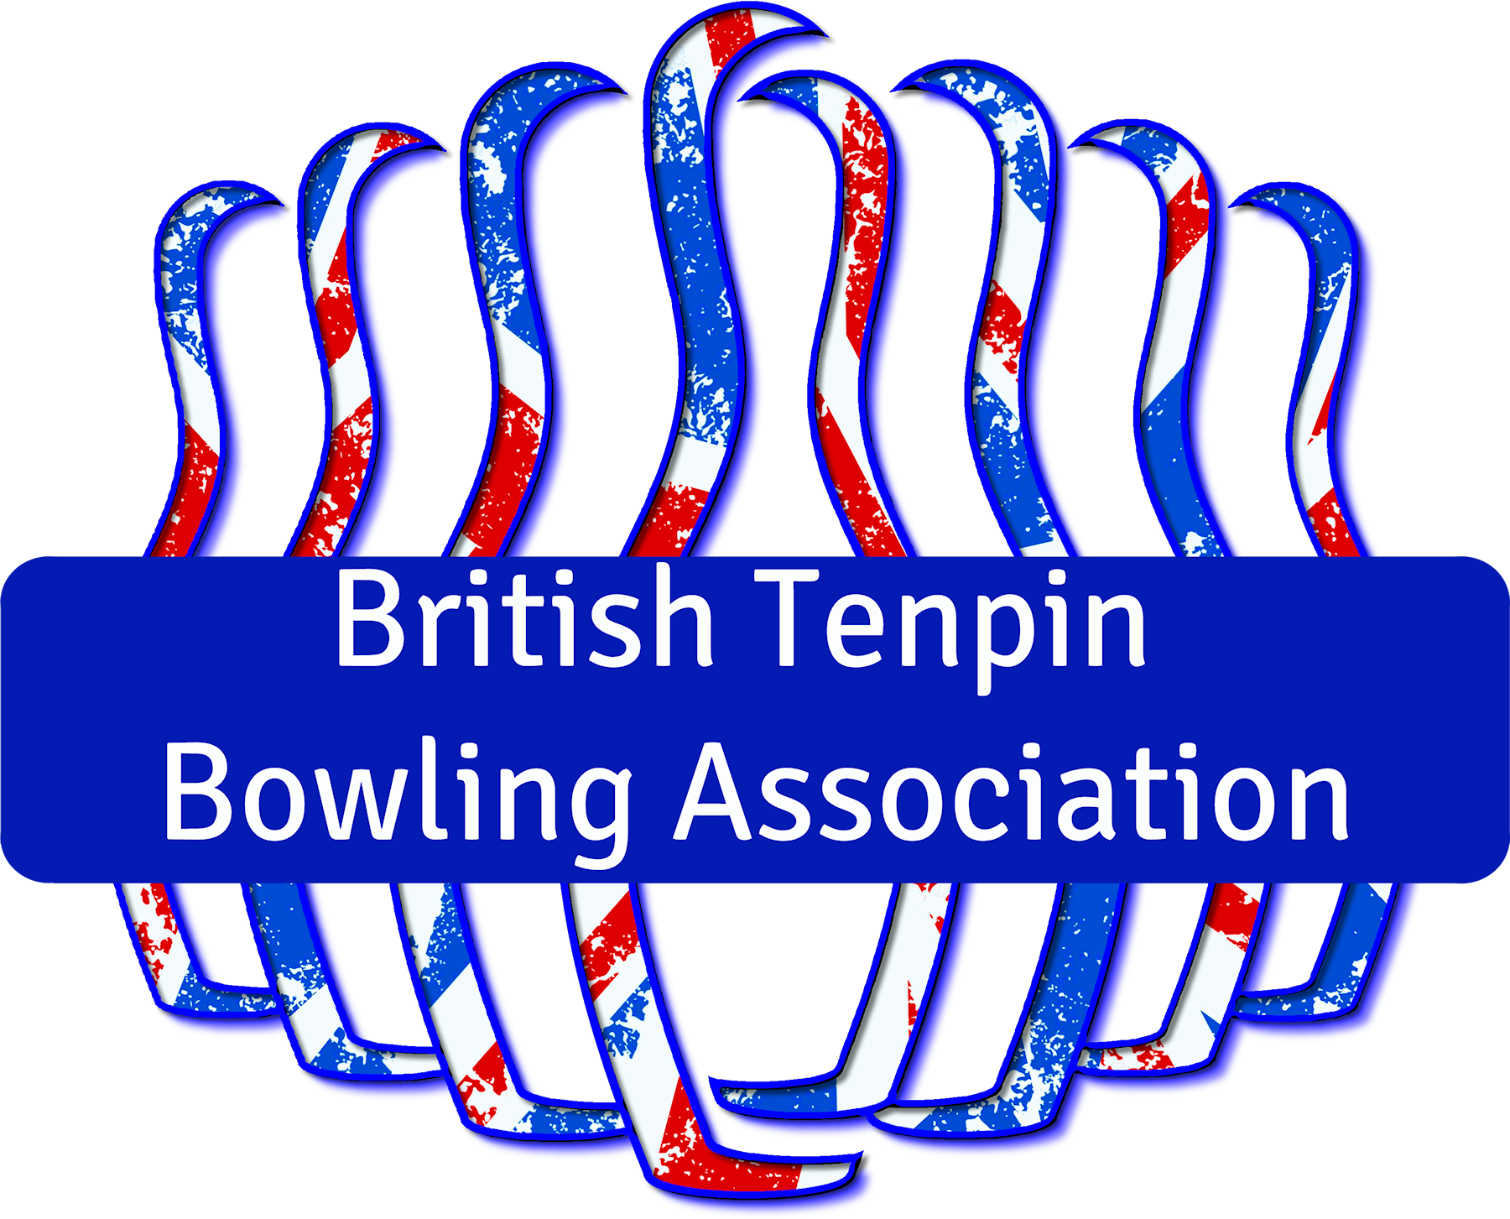

Youth Inter County
Championships 2023

12th & 13th August 2023

GOBowling Dunstable
Grove Park, Court Drive
Dunstable. LU5 4JD.

Tournament Information and
Athlete Registration

Managed on behalf of the BTBA by
1. Tournament General

The British Tenpin Bowling Association (BTBA) Youth Inter County Championships 2023 (YICC2023) takes place on Saturday 12th and Sunday 13th August 2023 at GOBowling Dunstable.

The Championships will be managed by Youth Bowling England (YBE) on behalf of the BTBA, and the Championships Manager is Stuart Watson (stuartwatson@btba.org.uk).

The Championships consist of two divisions, U16 and U22, made up of mixed squads of eligible athletes. U16 athletes must be under the age of 16 at any time in 2023, and U22 athletes must be under the age of 22 at any time in 2023. The U16 Division will bowl on Saturday 12th and the U22 Division on Sunday 13th. All athletes and coaches/officials should arrive promptly at 8.30am on the day of their division.

Teams of four athletes must be selected from their squad of up-to six. A team and its squad are registered together, and athletes may not swap between squads at any time.

Eligibility to play, coach or officiate will be checked on the BTBA Membership database. All squad members, coaches and officials must be current members of the BTBA and in good standing. Coaching and Officials Licences must be shown on arrival and clearly displayed at all times.

The General Playing Rules (May 2023), Tournament Rules (January 2022) and the Inter County Championship (ICC) Rules & Regulations 2023 (January 2023) of the BTBA will apply to the Championships, which can be found on the BTBA website by navigating from the homepage (http://btba.org.uk) to the Resources Menu.

The Championships is sanctioned by the BTBA, Sanction No. 23/00309.

2. Schedule and Format

The U16 Division will bowl 6 games for total pinfall moving lanes each game. Medals will be awarded for 1st, 2nd and 3rd places.

The U22 Division will also bowl 6 games for total pinfall moving lanes each game, but the top-four will enter a Round-Robin playoff for 1st, 2nd and joint 3rd.

3. Fees

Fees are £140.00 per squad. Fees must be paid by Monday 7th August 2023. Please remit to the following account using your County as reference.

Account Name | Stephen Toop
Sort Code | 60-20-03
Account No. | 34694978
Reference | Your County

4. Registration of Officials & Athletes

Please register your officials and athletes on the forms below, pages 4 – 7, and return to me via email to stuartwatson@btba.org.uk by Monday 7 August. You may wish to enter these details directly in this document on your computer and submit the entire document.

PLEASE NOTE:
We have included two team registration forms for each of U16 and U22 squads to facilitate Counties who have expressed intent to field two teams at one or both of U16 and U22.

REMEMBER to include the results of your Trials / Roll Offs with your registration

TEAM REGISTRATION

COUNTY
MANAGER
EMAIL
PHONE

U16 ‘A’ SQUAD
COACH
NAME | BTBA No.
ATHLETES
NAME | BTBA No.
NAME | BTBA No.
NAME | BTBA No.
NAME | BTBA No.
NAME | BTBA No.
NAME | BTBA No.
TEAM REGISTRATION

COUNTY
MANAGER
EMAIL
PHONE

U22 ‘A’ SQUAD
COACH
NAME | BTBA No.
ATHLETES
NAME | BTBA No.
NAME | BTBA No.
NAME | BTBA No.
NAME | BTBA No.
NAME | BTBA No.
NAME | BTBA No.
TEAM REGISTRATION

U16 ‘B’ SQUAD
COACH
NAME | BTBA No.
ATHLETES
NAME | BTBA No.
NAME | BTBA No.
NAME | BTBA No.
NAME | BTBA No.
NAME | BTBA No.
NAME | BTBA No.

TEAM REGISTRATION

U22 ‘B’ SQUAD
COACH
NAME | BTBA No.
ATHLETES
NAME | BTBA No.
NAME | BTBA No.
NAME | BTBA No.
NAME | BTBA No.
NAME | BTBA No.
NAME | BTBA No.

