TPT 2022 Introduction

A hybrid version of Tenpin Tour was successfully run during the period of 2021, when bowling centres opened after the Covid lockdown. It is intended to revert to our normal format for 2022 and we will continue the trial of a straight eight games shootout, as we were never able to complete the year that was requested by the membership. Plus, we feel that this is a more “Covid aware” approach to gathering what is, after all, a large number of senior and potentially vulnerable, bowlers.
In addition, we will continue with the practice of moving together on the lanes rather than the traditional left moves left and right moves right to reduce the direct interactions between bowlers. Finally, to protect everyone, we will be asking that all bowlers ensure that they have been fully vaccinated against Covid. We will assume that submission of an entry into the event is confirmation of vaccination or documented recovery.
The proposed dates and locations, where known, have been published on the website. Please note that while most of the events will still be held on Saturdays and Sundays, circumstances have forced us in at least one case to run squads on a Friday. We are hoping that those members who are able will help us all out by booking the Friday. As stated in 2020 the decision to remove the finals squad, is expected to remove some of the pressure on the Sunday afternoon squad, but we still expect it to be the preferred squad so we will continue with the 100-mile distance for priority that we used in 2019.
Membership of the Tour remains open to all members of the BTBA and members of other UK National Tenpin Associations that are affiliated to the BTBA. There will be no additional fee for becoming a member of the Tenpintour. As previously notified, we changed the age qualification so that bowlers that were 45 before Jan 1st 2019, would be eligible to play. This year players need to be 48 before Jan 1st 2022. Eventually we will be back to over 50’s only.
All information i.e. squad details, results etc, will be made accessible on the Tenpintour website which is available as a link from the main BTBA website www.btba.org.uk. Regular emails will be provided to all those members who register their interest via our mail chimp registration page. Please use the link here to register, update your personal information, or unsubscribe from receiving any further emails.
https://us14.list-manage.com/subscribe?u=37aeca69577e9636113665f2e&id=6a519afc50

Please Note: We are unable to accept communication regarding entries etc in any format other than through the “contact us” page on our website.
Please do not contact us via Facebook, text, messenger, phone, or email, other than the address below, as we are unable to guarantee receipt in time for us to respond. tenpintour@btba.org.uk
​

Playing Rules

General rules:
These tournaments will be sanctioned by the B.T.B.A. and their General playing and Tournament rules will govern this event, together with the following special rules.
- All bowlers shall bowl a single 8 game block, moving lanes after each 4 games. In most cases we will be playing at doubles pace, but this will ultimately depend on the number of entrants and lane availability. To reduce disruption when moving lanes all bowlers will be required to remain on their lanes until all games are completed and they are advised by the tournament manager to move lanes.
- Final placing will be determined by total pin fall plus handicap
- If there are any ties for prize places, the prize money will be shared equally among the competitors involved.
- A provisional ball must be rolled if a dispute relating to pin fall that cannot be resolved immediately.
- Protests must be made within 30 minutes of any infraction occurring and confirmed in writing within 72 hours to the Tournament Manager.
- The Tournament Management Committee reserves the right to reject any entry and their decision on all matters shall be final, subject to an appeal to the B.T.B.A.
- The consumption of alcohol is forbidden during a Squad.
- The consumption of tobacco including electric substitutes is forbidden during a Squad.
- Bowlers are asked to wear Bowling attire that has their names visible on the back.
- Bowlers will be expected to be in the centre for registration at least 30 minutes before the squad time. Practice to start 10 minutes before the scheduled squad time. Late bowlers will start at frame in progress when they arrive. Previous frames will count as Zero.
- For 2022, members must be 48 years of age before the 1st January 2022.
- Squads will be allocated on a first come, first-served basis, with priority for Sunday PM squad given to bowlers travelling more than 100 miles to the event. This priority window closes two weeks before the start of the next event or when all spaces have been filled by priority bowlers, whichever comes first. Bowlers not being allocated their first choice squad will be offered an alternative place based on the time and date of their entry and payment receipt.
- No entries will be allocated places unless both the entry and the payment have been received.
- Details of squad allocation will be provided on the TPT website. Initially updates will appear on the website 10 days after the event opens. A subsequent update will appear 7 days later, and any further updates will be released as appropriate. The date of the update will be shown on the website so that you can determine if your entry should be included.
- Entry Fees The entry fee for all Tour events will be £50.00. This will include £10.00 Prize Fund, £2 BTBA Sanction fee and £5 for the Order of Merit. Payments must be sent by Bank Transfer to the following account.
- Account Name: BTBA Tenpin Tour.
- Account: 20-44-22
- Sort Code: 20709794
Please ensure you use the TPT event and your BTBA number and surname as your payment reference, For example: TPT1 000509 Griffin

Handicaps:

The BTBA Tenpin Tour will be played as Handicap events
Handicaps will be calculated from a different scratch basis for Men and Ladies as follows:
- Men’s handicaps will be calculated using a Tour Average of 230.
- Ladies’ handicaps will be calculated using a Tour Average of 200.
The Bowlers Handicap will be 85% of the difference between their Individual Average and the Tour Average. Individual Bowling Averages will be adjusted before every tournament and will be published on the TPT Website.
Maximum handicaps for Men will be 70 and Women will be set at 80 pins.
These adjustments mean there is no longer a requirement for bonus points.
- It is the responsibility of all bowlers to ensure their handicap is correct, as this will NOT be INCREASED after play commences.

Individual Averages
Individual Averages shall be determined from existing bowling averages in the following precedence:
- Current Tenpintour tournament average over 18 or more games played within the previous 10 Tenpintour events .
- Tenpintour tournament average over 18 or more games played during the previous season i.e. for 2022 we will go back to Dunstable July 2019.
- Certified current highest league average (minimum 21 games) or Composite tournament average for events played in last 12 months (minimum 21 games) whichever is higher.
- Bowlers without current averages may enter the tournament with a handicap of scratch and their score will be used to determine their future Tenpin Tour Handicap after a minimum of 18 games have been bowled.
Players that only have averages based on Sport or Challenge patterns will be re-rated as follows. Challenge score +5%; Sport only +10% (combination of sport and challenge will be calculated pro-rata.)
- Where bowlers are unable to provide a Tenpintour average (options 1 & 2) their average will be reviewed after the initial 8 game block. If the average of these 8 games is more than 10% above the entering average, the players entering average will be re-rated to 2/3 of the difference between the entering average and the average bowled in the initial eight games. Example:
  - Entering average =180
  - Bowled average =210
  - Re-rated entering average would be =200
- Players will use either their entering average or their current Tenpintour average whichever is higher until they have achieved a Tenpintour average over 18 games. (Options 1 & 2 above)

Prize fund allocation

- Each entry will contain £10 prize fund and this will be the minimum amount that will be paid out at the end of each event.
- Prize money will be distributed by online payment into individual bank accounts within 3 days of the results being received by the administration team.
- All bowlers that finish in the top 33% (Approximately) will have their prize money of £10 paid back.
- The top finishers will receive a position bonus in addition to the £10 paid for qualifying using the following approximate proportions.
  - Men: 1st 33%, 2nd 20%, 3rd 15%, 4th 10%, 5th 8%, 6th 6%, 7th 5%, 8th 3%
  - Ladies: 1st 42%, 2nd 25%, 3rd 18%, 4th 15%
- Plus, the winners in each section will receive a BTBA Tenpintour Winners bowling shirt

Order of Merit
Order of Merit (OOM) ranking points will be awarded throughout the year based on final positions at each event.
OOM points will be awarded as follows:
- Men: 1st: 100 points, 2nd:99 points, 3rd: 98 points decreasing to 1 point for 100th place.
- Women: 1st: 50 points, 2nd: 49 points, 3rd: 48 points decreasing to 1 point for 50th place.
- Final Positions in the Order of Merit will be taken from your best 5 appearances from events held during the year.
The top 5 Men and 4 Ladies at the end of the season will receive a cash prize plus a non-transferable, complementary entry into the TPT Masters competition. Details of the winner’s prize packages are noted below. The estimated value of the packages is based on 2019 master’s costs and is subject to amendment as we develop the program for 2022. Accommodation will not be provided and the estimated costs will be included within the total cash prize awarded. See Table below for Prizes
In the event of tied positions, the prize money will be shared equally among the competitors involved and complementary entry into the Masters will be as follows.
- First Tie break the bowler with the Highest Individual Average at the conclusion of the season
- Second Tie break the bowler with the highest individual Scratch High Game during the season, or the next highest game and so on.

Proposed Order of Merit prize list

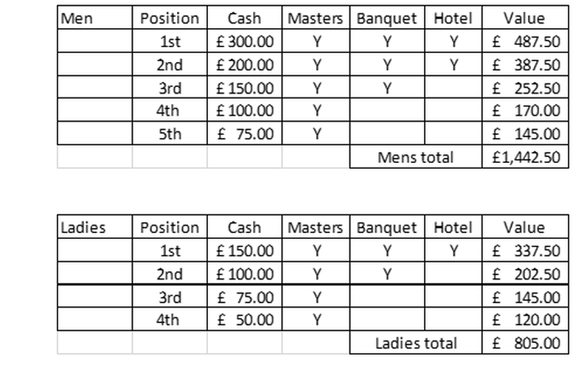

The BTBA British Tenpintour Masters (summary)
​
At the conclusion of the season, we will be running the BTBA British Tenpintour Masters. This will be a handicap event based on your Individual average at the conclusion of the season.
Eligibility for the event will be the same as for all BTBA Tenpin Tour events but you should have participated in 5 (five) events throughout the season to qualify. Depending on the number of entries received, we anticipate that there will be a separate Men’s and Ladies section.
The event will run from Friday to Sunday. Each bowler will bowl two qualifying blocks of 4 games, one block must be played on Friday and the other block can be played on either Friday or Saturday. Re-entries may be available from Friday afternoon and throughout Saturday.
Players will be cut after the qualification, 50% playing in the plate on the Sunday Morning and 50% playing in the Master in the afternoon.
Any bowlers that have significant difficulty bowling on the Friday should contact one of the TPT admin team to see if we are able to assist in any way.
Full details of the Masters event will be published within a separate brochure later in the season

